Operational Programme | Technical Assistance
Specific objective | no. 1 To ensure the stabilization of the officials of the subjects involved in the management, control and audit system of ESIF
Name of beneficiary | Government Office of the Slovak Republic
Project name | Implementation of the Central Educational Plan for the European Structural and Investment Funds administrative capacities in the year 2016
Project summary | Implementation of the Central Educational Plan for the ESIF administrative capacities laid the basis for the establishment of the system management and training strategy for the administrative capacities in the 2014 - 2020 programming period, which the Slovak Republic undertook to adopt in the Partnership Agreement as one of the key document for increasing the efficiency and quality of administrative capacities.  The objective of the project is to create and implement sustainable education system for standardized and non-standardized job positions for ESIF implementation bodies, involved in the management, implementation, control and audit of the ESIF during the 2014 - 2020 programming period.  The project set clear rules for education of EU officers based on the Competency model and the activities performed at their positions. The basic principles are a system approach to education, flexibility, orientation to the practical use of knowledge and skills and the quality of education.  The project set a file of mandatory and optional training modules that are designed for each standardized and non-standardized positions. This system approach will continue throughout the whole programming period.  At the same time, the project created unified electronic database of all administrative capacities – CEP Portal, which records the completed training courses according to the positions and the time period.
Start date of project implementation | January 2016
End date of project implementation | March 2017
Total Eligible Expenditure | 1 297 480,15 EUR
Amount of the non-repayable financial contribution | 1 297 480,15 EUR

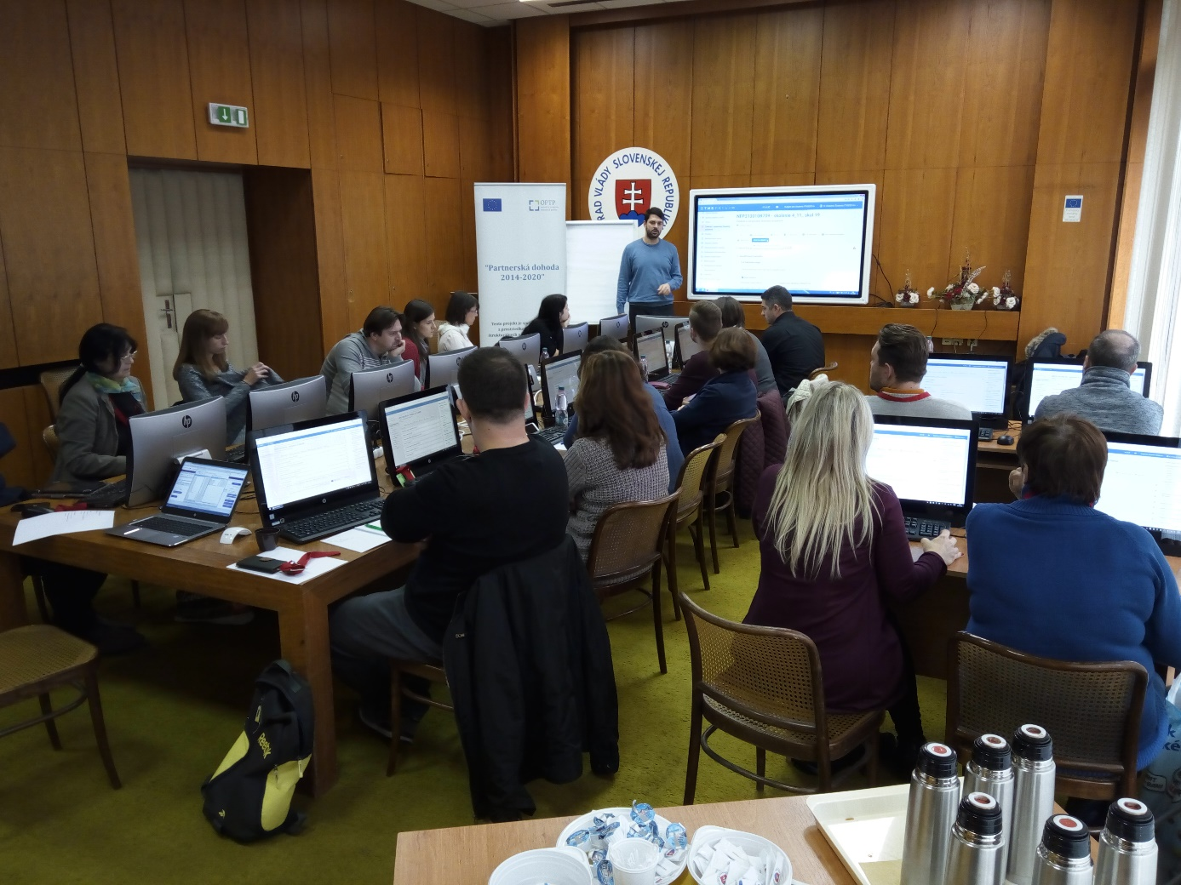
Training „ITMS 2014+ (Project and Financial Management)“, 04.11.2016

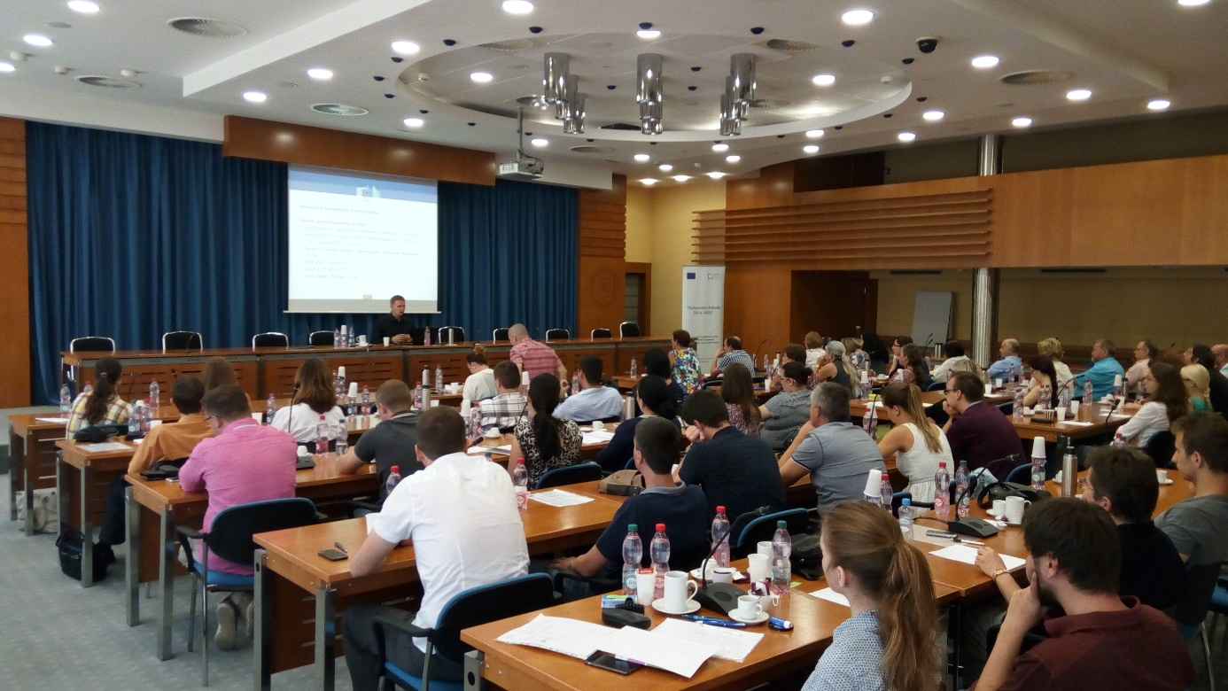
Training „Management System for ESIF 2014 – 2020“, 21.07.2016
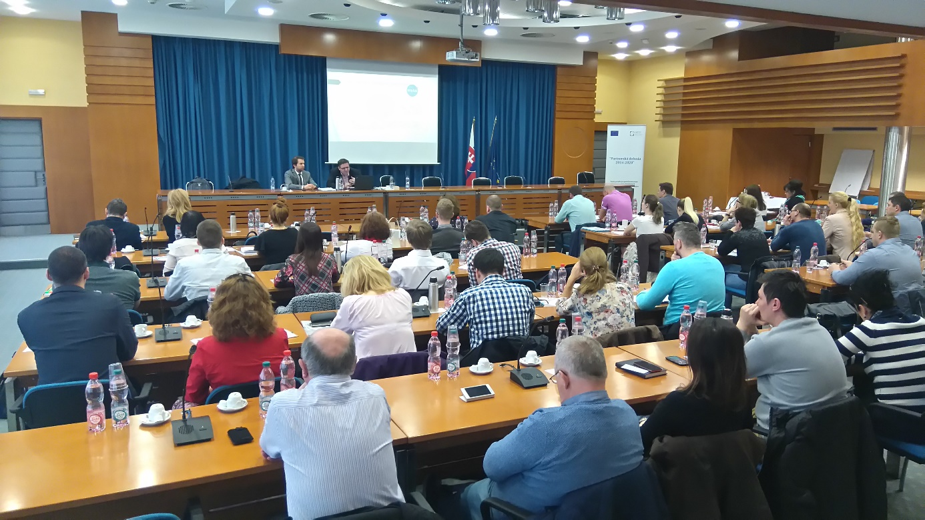
Training „Old Public Procurement Act vs. new Public Procurement Act“, 29.03.2016

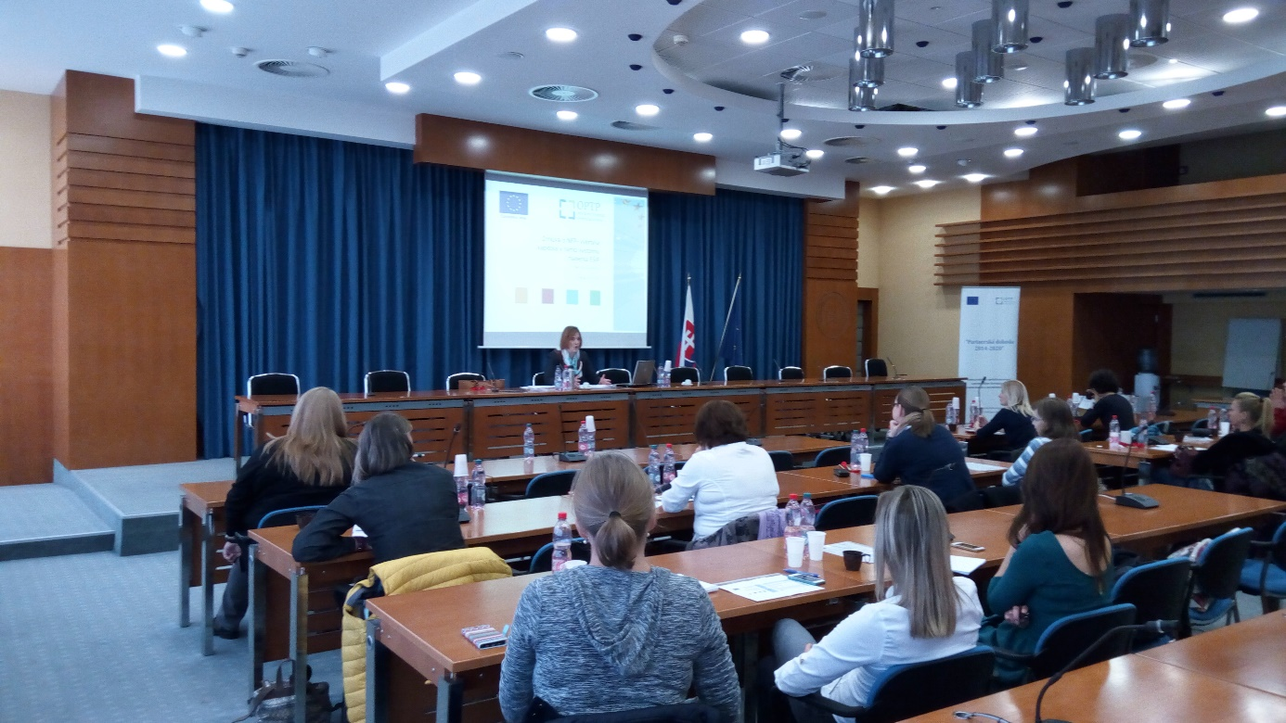
Training „Non-repayable financial contribution agreement – selected chapter of Management System for ESIF 2014 – 2020“, 03.11.2017

